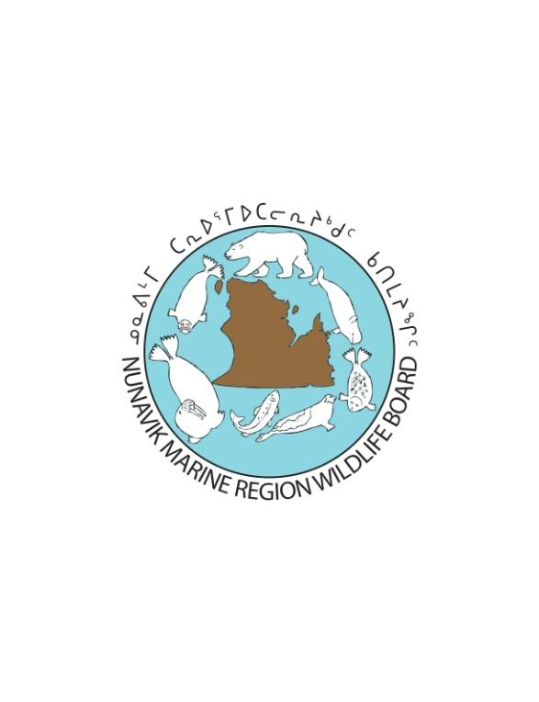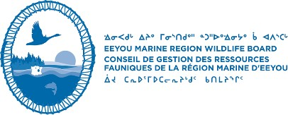

**NOTICE OF NUNAVIK MARINE REGION WILDLIFE BOARD and**

**EEYOU MARINE REGION WILDLIFE BOARD JOINT WRITTEN PUBLIC HEARING**

**to consider approval of**

**The Quebec - Eeyou Marine Region - Nunavik Marine Region**

**Polar Bear Management Plan**

**Notice is provided** on June 28th, 2021, that the Nunavik Marine Region Wildlife Board ("NMRWB") and the Eeyou Marine Region Wildlife Board (“EMRWB”) will be conducting a Joint Written Public Hearing to consider the proposed Quebec, Nunavik Marine Region and Eeyou Marine Region Polar Bear Management Plan (“QC-EMR-NMR Polar Bear Management Plan”) and to determine whether to approve the plan for application in the Nunavik Marine Region in accordance with s. 5.2.4(d)(i) of the Nunavik Inuit Land Claims Agreement (“NILCA”), in the Eeyou Marine Region in accordance with s. 13.2.2 (d)(i) of the Eeyou Marine Region Land Claims Agreement (“EMRLCA”), and in the Cree/Inuit Overlapping Interest Areas in accordance with Part IV of the Agreement Relating to the Cree/Inuit Offshore Overlapping Interest Area.

The proposed QC-EMR-NMR Polar Bear Management Plan and additional documents relevant to the joint hearing are available for download from the NMRWB’s website (nmrwb.ca/2021polarbearmanagementplan) or by contacting the NMRWB or the EMRWB using the contact information below.

**Parties with Standing** to this joint hearing include:

* Makivik Corporation
* Government of Canada
* Government of Nunavut
* Any LNUK
* The RNUK
* Any Nunavik Inuk
* Cree Nation Government
* Eeyou Istchee Local Cree Bands
* Eeyou Istchee Local Cree Trappers’ Associations
* Any individual Cree of the Eeyou Istchee
* Nunavut Tunngavik Incorporated
* Nunatsiavut Government

**Applications for Party Status** by individuals or organizations not listed above may be submitted to the NMRWB/EMRWB in writing **no later than July 9th, 2021.** The Application must contain information that shows how a right or interest of the applicant would be directly impacted by the decision to be made by either Board.

The NMRWB/EMRWB further issue an **Information Request** to all Parties with Standing, as well as any individuals and/or organizations that may have relevant reports, studies or information that would assist the Boards in this hearing. The deadline for filing relevant information is **July 9th, 2021**.

Parties with Standing may submit **Written Questions** in relation to the QC-EMR-NMR Polar Bear Management Plan proposal to the Boards. The deadline for submitting written questions is **July 30th, 2021.**

**Final Written Submissions** from Parties with Standing to the hearing, including answers to written questions, must be submitted by **September 24th, 2021**.

Unless persuasive written reasons are provided for late filing, the Boards will not consider materials for this hearing that are not filed on time. The Boards will make publicly available all written materials filed with them one week after filing deadlines, subject to relevant confidentiality or privacy concerns.

**How to obtain more information**

To receive more information please contact the NMRWB or the EMRWB:

|  |  |
| --- | --- |
| **NUNAVIK MARINE REGION WILDLIFE BOARD**  P.O. Box 433,  Inukjuak, QC J0M 1M0  Phone: (819) 254-8667  Fax: (819) 254-8816  Email: info@nmrwb.ca | **EEYOU MARINE REGION WILDLIFE BOARD**  P.O. Box 580 4, Chief Isaiah Salt Road Waskaganish, Quebec, J0M 1R0 Phone: 819-895-2202 Fax: 819-895-2474  Email: wildlife@eeyoumarineregion.ca |