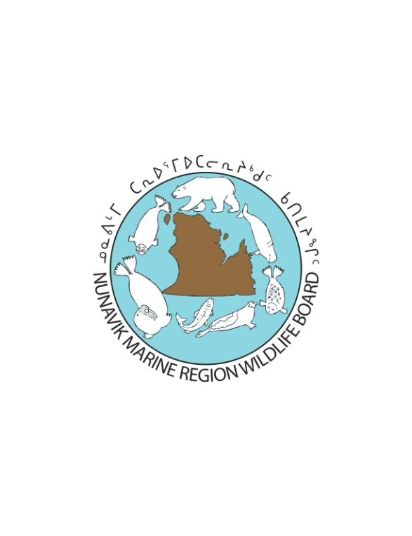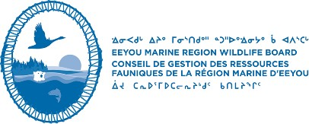

|  |
| --- |
| **Purpose and Rules for Nunavik Marine Region Wildlife Board and the Eeyou Marine Region Wildlife Board’s Joint Written Public Hearing to Consider the QC-EMR-NMR Polar Bear Management Plan** |

**THE PURPOSE** is to conduct a joint review of the proposed Quebec, Nunavik Marine Region and Eeyou Marine Region Polar Bear Management Plan (“QC-EMR-NMR Polar Bear Management Plan”) and to determine whether to approve the plan for application in the Nunavik Marine Region in accordance with s. 5.2.4(d)(i) of the Nunavik Inuit Land Claims Agreement (“NILCA”), in the Eeyou Marine Region in accordance with s. 13.2.2 (d)(i) of the Eeyou Marine Region Land Claims Agreement (“EMRLCA”), and in the Cree/Inuit Overlapping Interest Areas in accordance with Part IV of the Agreement Relating to the Cree/Inuit Offshore Overlapping Interest Area.

The purpose of this hearing is specifically the following:

**Consider approval of the proposed QC-EMR-NMR Polar Bear Management Plan**

The Proposal, along with other documents comprising the best available information to date, is available for review or download from the NMRWB's website (nmrwb.ca/2021polarbearmanagementplan).

**HEARING RULES:**

1. The hearing shall be conducted by way of a joint written public hearing. Information may be filled by any member of the public. However, participation, such as posing questions and filing submission is limited to Parties with Standing.
2. Parties with Standing included those identified in the ss. 5.6.24, 27.6.4 and 29.3.9 of the NILCA and ss. 14.6.2 of the EMRLCA.
3. Individuals or organizations that demonstrate an interest in the decision to be made may make an application to the Boards to have Party Status.
4. Late filing of applications, documents, or submissions will not be accepted unless persuasive written and translated reasons are provided to the NMRWB or EMRWB explaining late filing. Materials for this hearing that are not filed on time will not consider.
5. The requirement for translation of submissions and supporting documentation filed with the NMRWB and the EMRWB does not apply to individual members of the public.
6. For all others who file supporting documentation with the NMRWB and the EMRWB, the requirement for translation does not apply to such documents over ten (10) pages in length, if each supporting document that is not translated is accompanied by a concise, translated summary (English and Inuktitut) at least two (2) pages in length.
7. The NMRWB and the EMRWB shall ensure that all materials filed with it or produced by it are made publicly available, subject to relevant confidentiality or privacy concerns.
8. The NMRWB/EMRWB will allow for the filing of questions in relation to the Proposal. Parties as well as board members may put forward questions. Answers to the questions will be provided by the organizations that submitted the Plan for approval. All answers will be made publicly available, subject to relevant confidentiality or privacy concerns.
9. The NMRWB and the EMRWB will conduct all meetings and deliberations on the matter jointly. Those with observer status under NILCA 5.2.2 and the EMRLCA 13.1.2, may have technical advisors attend such meetings and deliberations. The NMRWB and the EMRWB reserve the right to hold in-camera meetings with their legal counsel, with the exclusion of observers, at any time throughout the hearing and the decision-making process.
10. Although the process is being conducted jointly, the NMRWB and the EMRWB will independently exercise their respective authorities under the respective Land Claims Agreement. However, for the Joint Zone, as defined in the Cree/Inuit Offshore Overlap agreement, the NMRWB and the EMRWB with jointly and equally exercise their authority.
11. The EMRLCA and the NILCA allow for the approval of a management plan, the boards have no authority to vary the management plan. However, prior to deciding and sending the decision to the Minister, if the Boards conclude that there are omissions or errors in the proposed plan, the Boards may request the party that submitted the plan consider making amendments to address the omissions or errors. This is within the submitting party’s desecration whether to make the suggested amendments or not.

***Written Public Hearing- Public Process***

|  |  |  |
| --- | --- | --- |
| **Timelines** | **Steps** | **Deadlines** |
| DAY 1 | Issue Notice of Written Public Hearing re: review and approval of the PB MP  -Included in the Notice of Written Public Hearing will be an Information Request of all parties | June 28th launch |
| 2 weeks | 1) Parties to respond to the Information Request and to file their information with the EMRWB/NMRWB joint registry.  2) filing request for party status. | July 9 filing deadline |
| *1 week internal processing time* | *1) Processing and posting the responses to the Information Request*  *2) processing Request of Standing (review and Board either approve of reject)\** | July 12-16th week |
| 2 weeks | Parties to filing their questions about the Draft Management Plan or any of the documents in the record with the Boards/registry.  Boards to also develop their questions during this time | July 30th filing deadline |
| *1 week internal processing time* | *POSTING on the registry the questions and issuing the questions to the parties that can answer them.* | August 2-6th week |
| 3 weeks | Parties to answer the questions they receive and to file their answers with the Boards/registry. | August 27th filing deadline |
| *1 week internal processing time* | *Post responses* | August 30th-September 3rd week |
| 3 weeks | Allow for parties to make final submissions | September 24th filing deadline |

***Internal Deliberation Process***

Staff to develop Briefings that summarize the submissions and information

Staff/Board members review of submissions and other documents

Deliberation #1: Option for consideration to hold joint Deliberation during the week of October 19-21st in MTL. EMRWB currently scheduled to meet this week.

Approve

Boards unable to approve as is and conclude amendments are required.

Submit decision to the Ministers

Provide summary of changes being requested by the Boards along with reasons in support of the changes to the Polar Bear Working Group and provide them an opportunity to amend the Plan.

PB Working group respond (either with amendments to the Plan or without any amendments and reasons why not amending)

No-PB working Group opts not to make changes to PLAN

YES-PB Working Group amend the PLAN

Boards Deliberation #2: make Decision to approve or not

Parties provided with Amended Plan and given 2 weeks opportunity to comment

Decision Submitted to the Ministers